Name: ___________________________________________ Period: ________ Date:_________________

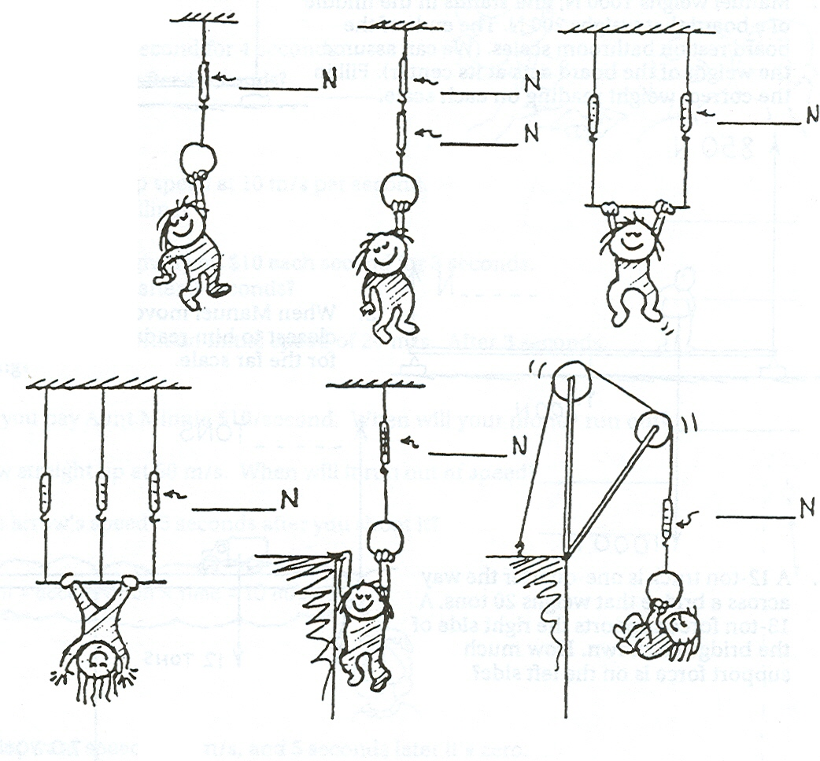
If little Nellie Newton weighs 96 N, fill in the 5 scale readings in the pictures below.

If Burl is standing in the middle of the staging in the first picture, write the scale readings for the other scales.
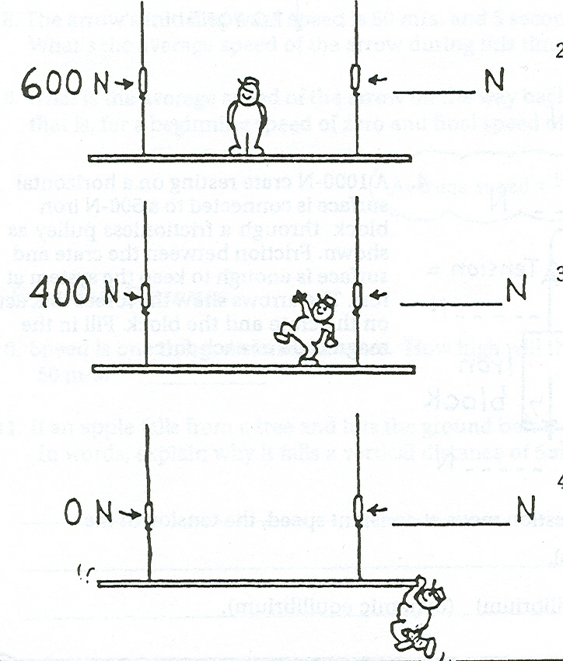
800 N
What is the total weight of Burl and the staging?

___________

OVER

Name: ____________________________________ Period: ______________ Date: _____________
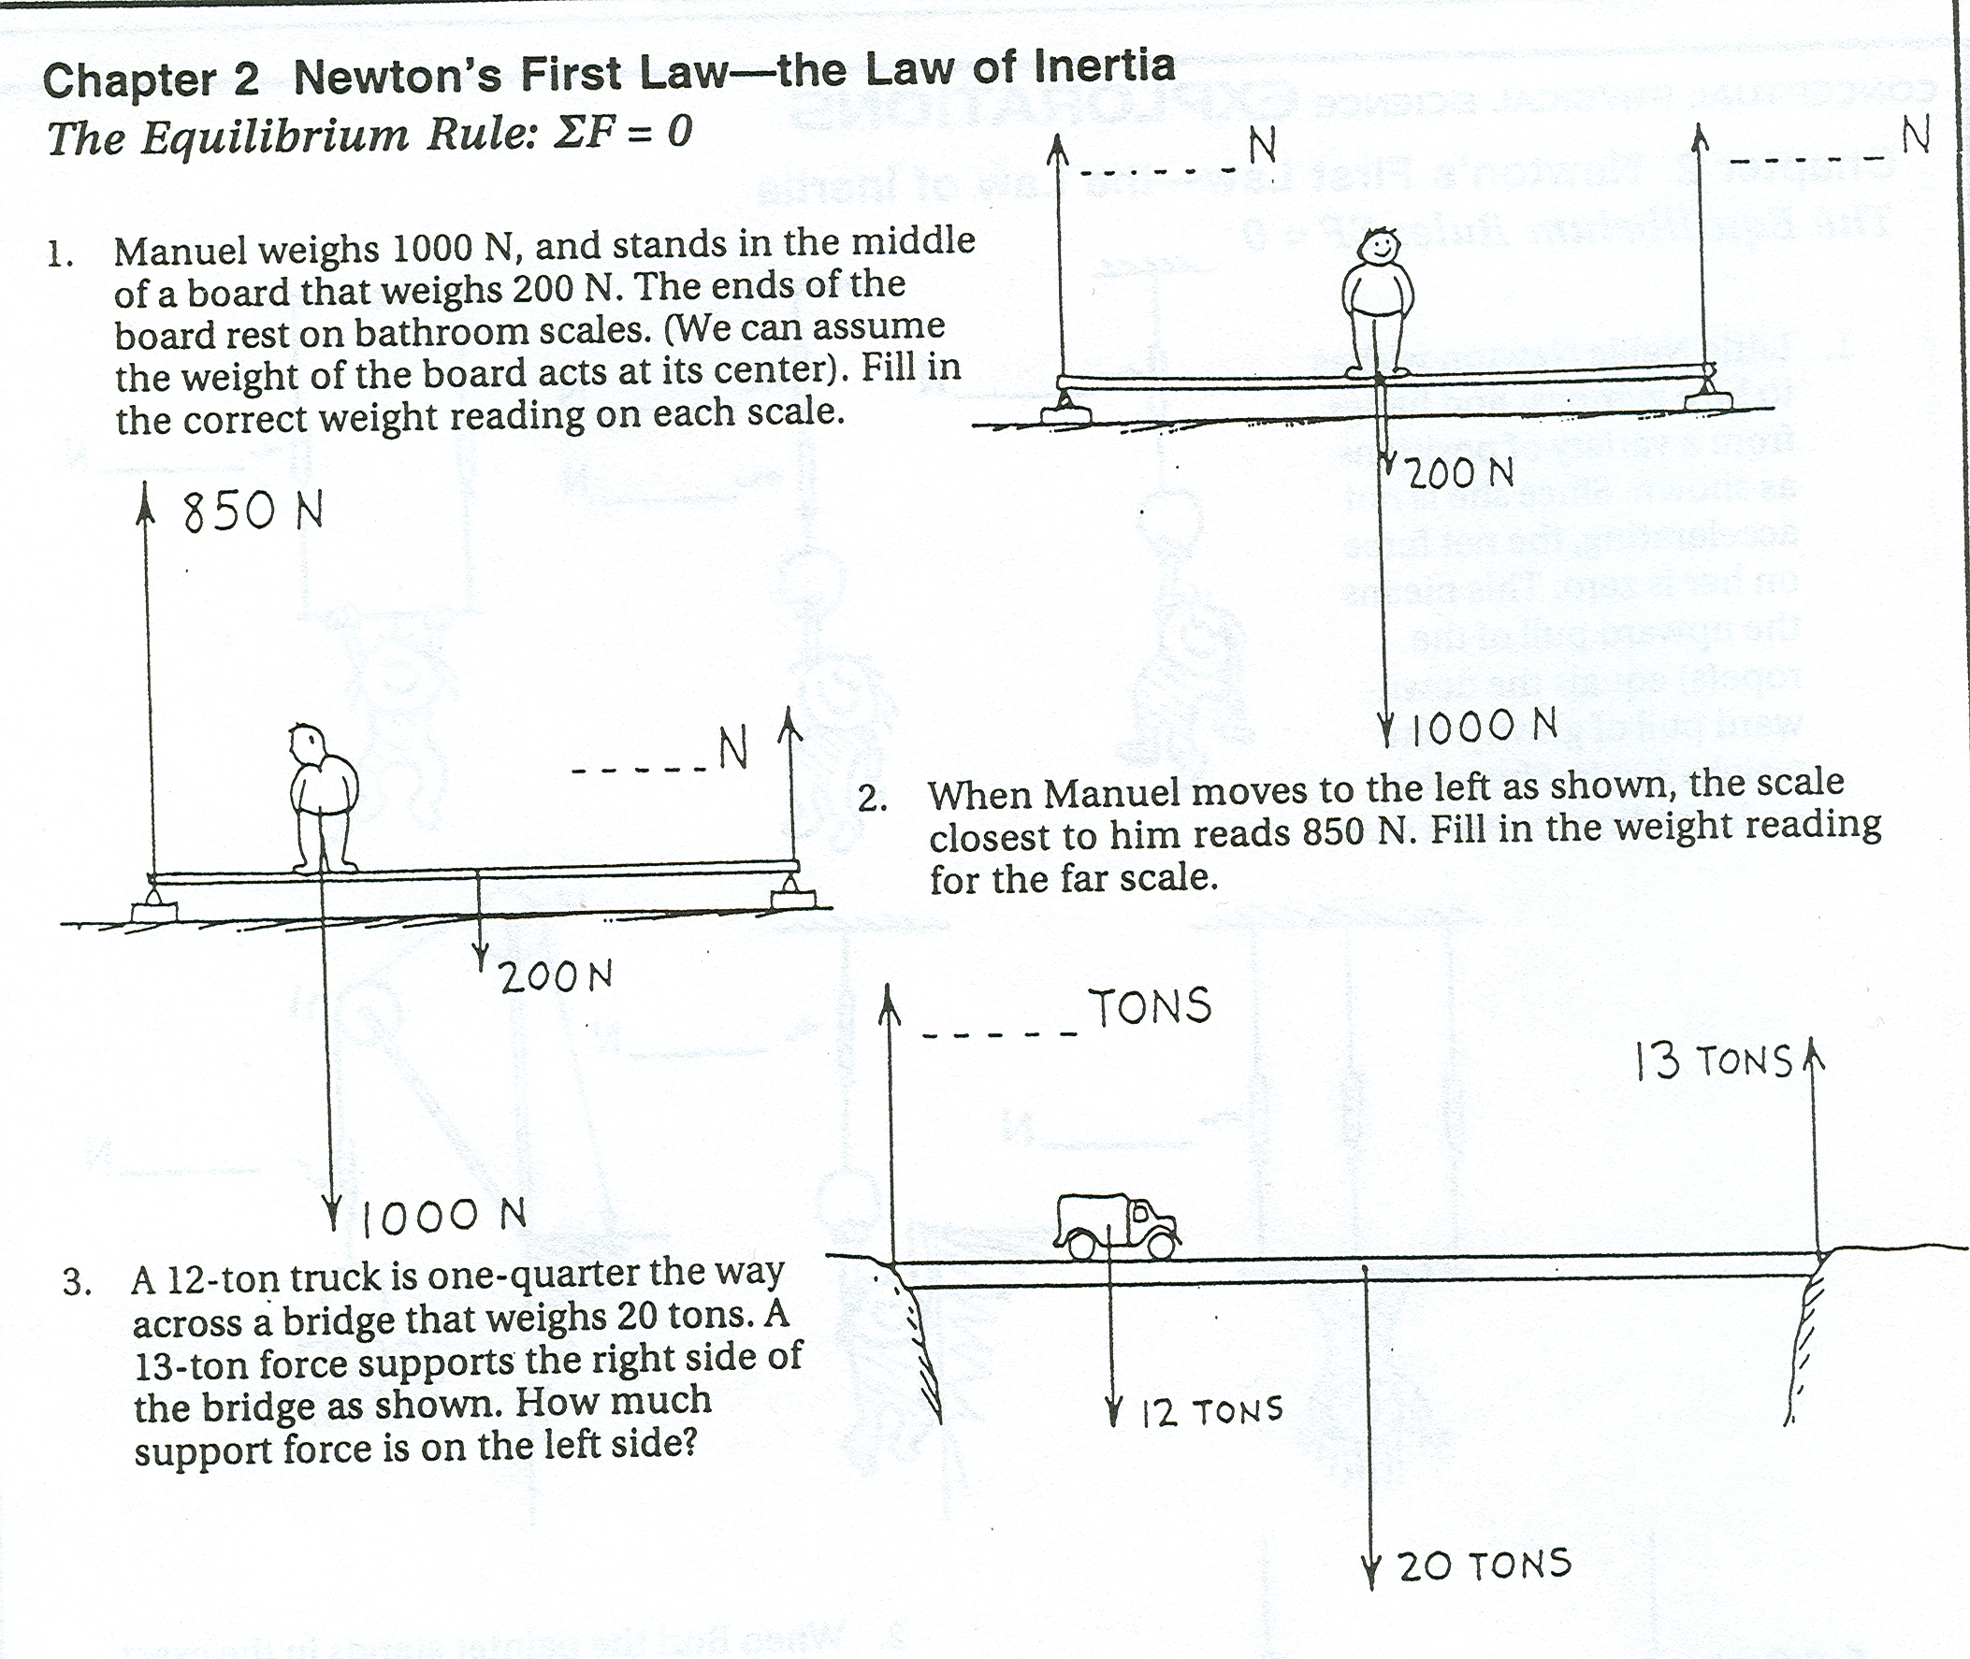
250 N
1250 N
_______N
_______N
250 N
1250 N
1050 N
_______N
________ tons
15 tons
25 tons
10 tons
Fill in the blanks using the information given in each picture.

Determine the net force for each of the following:

5 N Right 5 N Left 1) ΣF =
1.

3 N Right 1 N Left 2) ΣF =
2.

3 N Left 2 N Right 3) ΣF =
3.

4 N Left 4 N Right 4) ΣF =
4.

5. What is the largest force present in the above examples? __________________

6. What is the largest net force present in the above examples? ___________________

7. Which of the force pairs above would cause acceleration on an object? __________________

8. Which of the force pairs above represent equilibrium? ____________________

