Name: _____________________________________________ Pd.___________Date: _____________________________________
Atoms: Development of the Atomic Theory
Democritus
- 460 BC - Greek philosopher proposes the existence of the _____________________
- He pounded materials until he made them into smaller and smaller parts

- He called them “atoma” which is Greek for “______________________________”.

Democritus’s Theory:
All atoms:
- Are ____________________, _____________________ particles

- Are made of a single material formed into different ____________________ and _________________

- Are always ________________________, and they form different materials by ________________ ______________________________.

John Dalton
- 1803 - British chemist
- Elements combine in _______________________ _______________________ to form _________________________.

Dalton’s Model:

Solid Sphere Model or _____________________________________________

Dalton’s Theory:
- All substances are made of atoms that cannot be ____________________, ___________________, or _____________________________.
- Atoms join with other atoms to make new _________________________________.
- Atoms of the same element are _____________________ ___________________, and atoms of different elements are different in ____________________ and ____________________________.
J.J. Thomson
- 1897 - English chemist and physicist
- Discovered ____________________ _________________________________ _________________________________

Thomson’s Model:

__________________________ _________________________ Model or
__________________________ __________________________ Model

Thomson’s Theory:
- Used __________________ __________________ ______________________ to conduct his experiments.

- Atoms contain negatively charged particles called ______________________ and positively charged matter.

- Created a model to describe the atom as a sphere filled with positive matter with negative particles mixed in.

Cathode Ray Tube
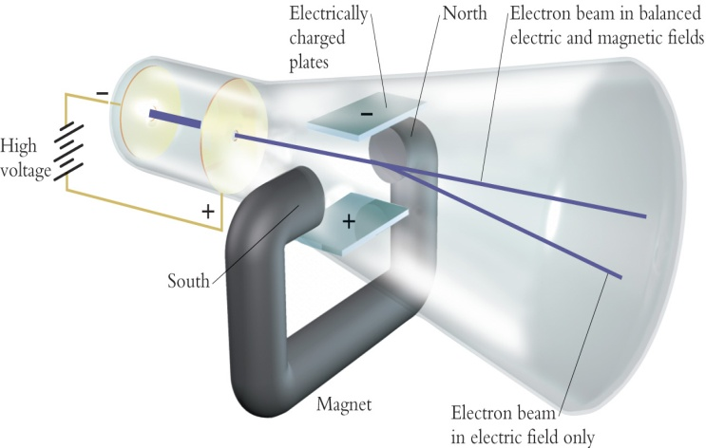

Ernest Rutherford
- 1912 - New Zealand physicist
- Discovered the ______________________________________

Rutherford’s Model:

_________________________________ Model

Rutherford’s Theory:
- Used ______________________ _________________________ _________________________ for his research.

- Small, dense, positively charged particle present in _____________________ called a ________________________________.

- ____________________________ travel around the _________________________, but their exact places cannot be described.

Gold Foil Experiment
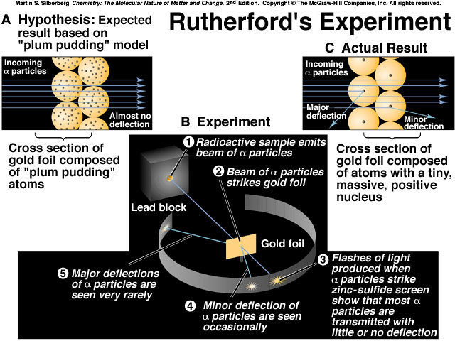

Niel’s Bohr
- 1913 - Danish physicist
- Discovered ____________________________ _________________________________

Bohr’s Model:
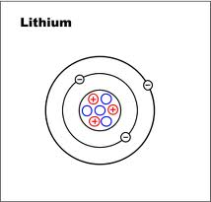

____________________ Model

Or

__________________________ Model

Bohr’s Theory:
- ______________________________ travel around the nucleus in ________________________ __________________ and __________________________________ ______________________________________.

- Electrons can ___________________________ from one level to a path in another level.

Erwin Shrodinger
- 1924 - Austrian physicist
- Developed the electron cloud model

Shrodinger’s Theory:
- The exact path of electrons cannot be predicted.

- The region referred to as the electron cloud, is an area where electrons can likely be found.

Modern Theory of the Atom
- Atoms are composed of three main subatomic particles:
- ___________________________________
- ____________________________________
- ____________________________________
- Most of the mass of the atom is concentrated in the _________________________________ of the atom.
- The _________________________________ and _______________________________ are located within the nucleus, while the _______________________________ exist outside of the nucleus.
- In neutral atoms, the number of protons is equal to the number of _________________________________.
- The type of atom is determined by the number of _____________________________ it has.
- The number of protons in an atom is equal to the ___________________________ number.
- The sum of the number of protons and neutrons in a particular atom is called the _____________________ _________________________.
- ____________________________________ electrons are the outermost electrons.

