Name: _________________________________________________ Date: ______________ Period: ____

General Science – Chapter 6 Review
The box weighs 1000 N
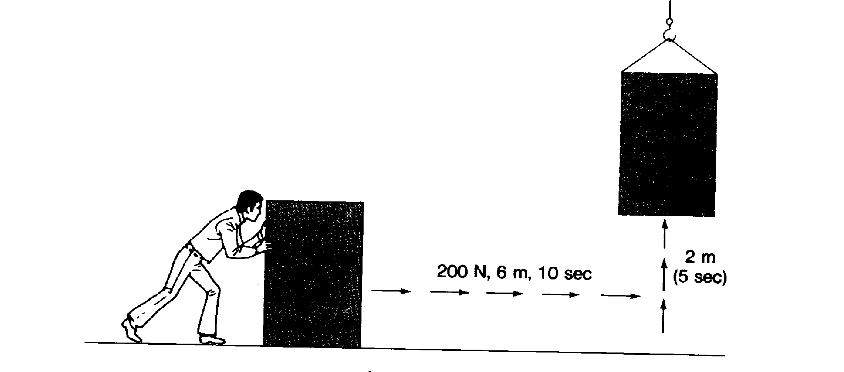
Solve the following problems. Show your work. Include a label.

1. Work done sliding box across floor 1_______________

2. Power to slide the box across the floor 2_______________

3. Potential energy of the box after sliding it 3_______________

4. Work done lifting box 4_______________

5. Power to lift box 5_______________

6. Potential energy of the box after lifting it 6_______________

