Name: _______________________________ Pd. _______ Date: _________________
Geology Concept Check #1
- Name two (2) pieces of evidence that indicate that the Earth is round. (1 point)

  - ____________________________________________________________________________________

  - ____________________________________________________________________________________

- Earth is a(n) __________________ (.5 points)
  - sphere
  - oval
  - oblate spheroid

- Match the classes of geological events to their descriptions (2 points)

  - changes in slope _________ tectonic
  - eruptions _________ gradational
  - objects collide with the Earth _________ volcanic
  - caused by earthquakes _________ impact craters

- Using the events in question 3, which geological event occurs the most frequently? __________________ (.5 points)

- Using the events in question 3, which geological event is the most random? ________________________ (.5 points)

- It is possible for one geological event to cause another geological event? True or False (.5 points)
- In order to determine how old a geological feature is compared to other features, geologist use: ___________
___________ (.5 points)

- Order the layers of rock from oldest to youngest (2.5 points)
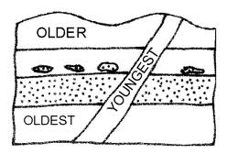
___________ oldest
___________
___________
___________
___________ youngest

E
D
C
B
A

