Name: _____________________________________ Date: ___________________ Period: ______

Solve the following problems. ***Show your work.*** Include a ***label.***

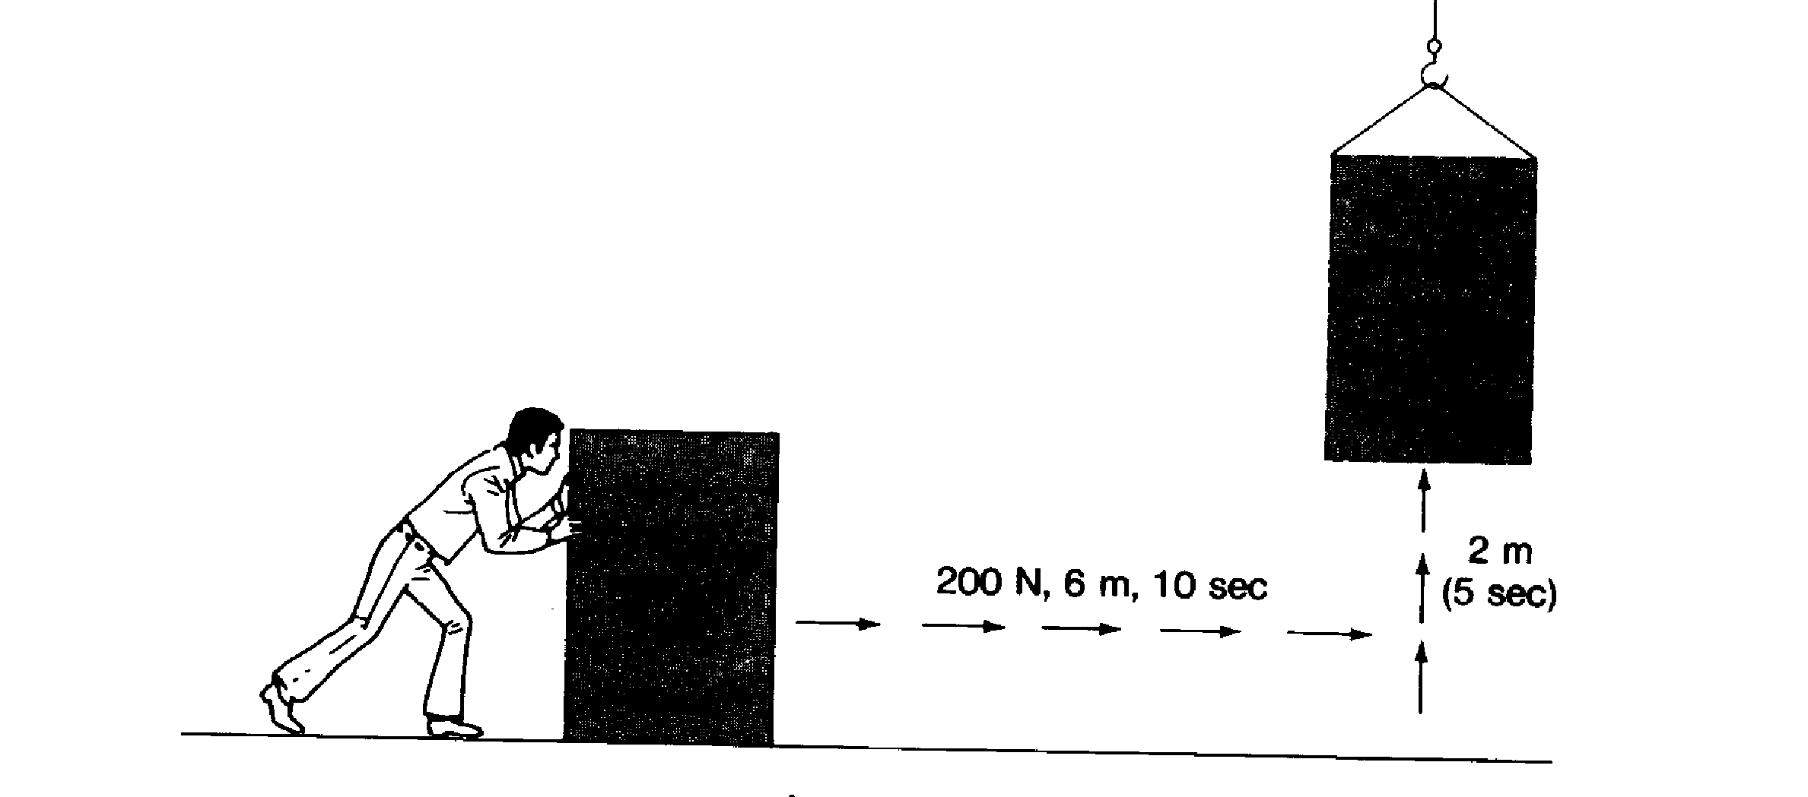

7 m

60 sec

723 N, 15 m, 120 sec

The box weighs 1230 N

1. Work done sliding box across floor ________________

2. Power to slide the box across the floor ________________

3. Work done lifting box ________________

4. Power to lift box ________________

MCj01210850000[1]

MCj01414210000[1]MCj01393310000[1]5. Three divers with the **same mass** are pictured to the left. The potential energy for all three is given. Determine the kinetic energy for each diver.

PE = 4,500 J

KE = ___________

(hint: he hasn’t jumped yet!)

PE = 1,000 J

KE = ____________

PE = 2,700 J

KE = ____________