Name: _____________________________________ Date: __________________Period: _____________

Solve the following problems. Show your work. Include a label.

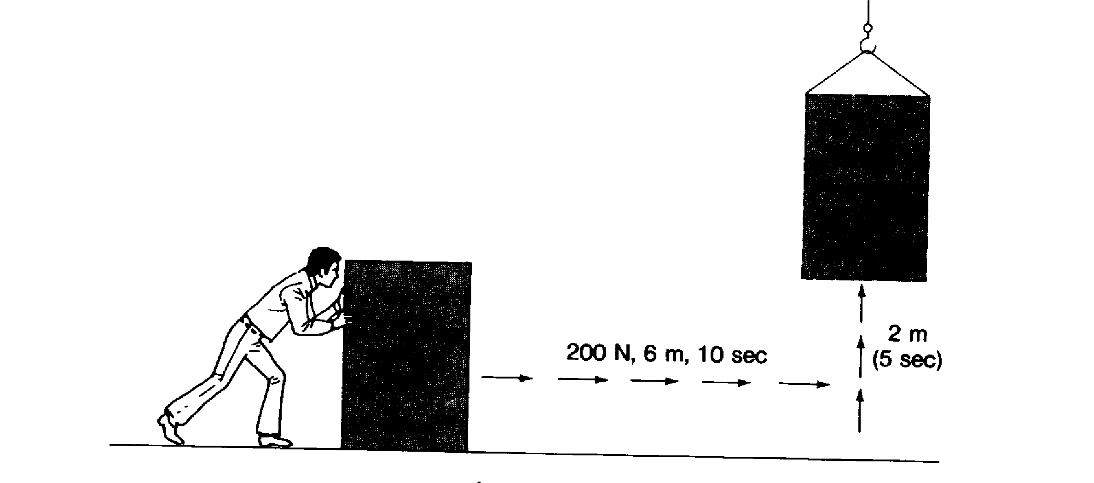
The box weighs 425N
100N, 5m, 4 sec
3 m
2 sec

1. Work done lifting box ________________

2. Power to lift box ________________

3. Potential energy of the box after lifting it ________________

4. Work done sliding box across floor ________________

5. Power to slide the box across the floor ________________

6. Potential energy of the box after sliding it ________________

X
Y
Z
7. What letter represents the highest Kinetic Energy? _______

8. What letter represents the lowest Kinetic Energy? _______

9. What letter represents the highest Potential Energy? _______

10. What letter represents the lowest Potential Energy? _______

