Name: ________________________________________ Pd. ______ Date: ___________________________

**Meteorology Unit Study Guide**

1. **Define meteorology**
2. **The most abundant gas in the atmosphere by volume is _________. This gas comprises 78% of the Earth atmosphere by volume.**

a. Oxygen     b. Argon   c. Carbon Dioxide   d. Nitrogen

1. **In what part of the atmosphere does the vast majority of our weather take place?**
2. Mesosphere b. stratosphere c. troposphere d. thermosphere
3. **Name the 3 big weather characteristics**
4. _______________________________________
5. _______________________________________
6. _______________________________________
7. **In terms of pressure, how does air move?**
8. **In general, _____________ pressure means we will have nice weather. _____________ pressure means we will have bad weather.**
9. **When measuring pressure on a weather map, these are the lines that connect areas of equal air pressure.**
10. Isotherms
11. Isotachs
12. Isobars
13. **High wind speeds mean isobars** (are closely spaced / are widely spaced).
14. **What are the two rules for isobars?**
15. ______________________________________________________________________________________
16. ______________________________________________________________________________________
17. **What instrument is used to measure air pressure?** ______________________________
18. **In the northern hemisphere, which way does air move/flow near areas of high pressure?**
19. Directly towards low pressure b. Counter-clockwise c. Clockwise d. North to south
20. **Match the term with the correct definition**

_____Temperature A. Weight of the atmosphere in a particular place at a particular time

_____ Air Pressure B. Amount of heat in the atmosphere

_____ Humidity C. Amount of moisture (water vapor) in the atmosphere

1. **Use the Air Pressure Map to complete the activities that follow:**

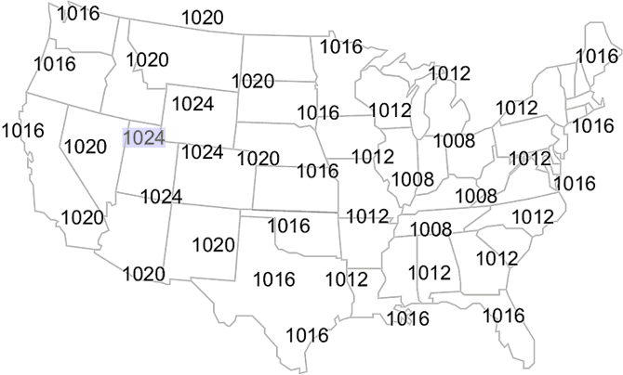

**13a.** Draw in your isobars

**13b.** Label the center of the high pressure area with a large "H".

**13c.** Label the center of the low pressure area with a large "L".

**13d**. Shade, in green, the state(s) would you expect to see rain or snow.

**13e**. Shade, in yellow, the state(s) would you expect to see clear skies.

1. **Explain the jet stream**
2. **Look at the figure below; if the jet stream shifts north what affect will it have on the temperature in the north? The south?**

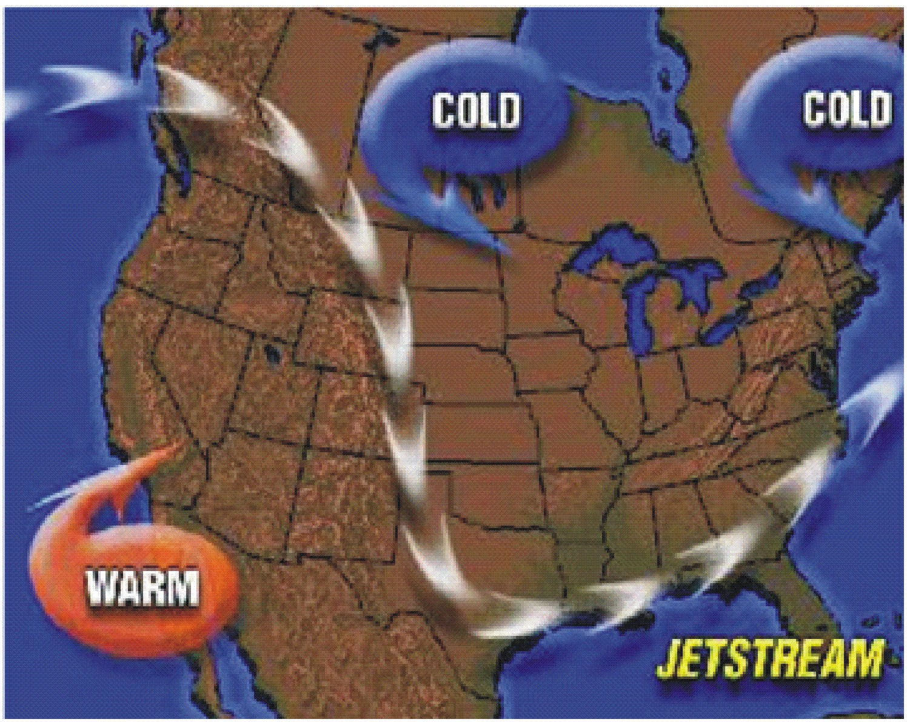

**north**: ______________________________

**south**: ______________________________

1. **What instrument is used to measure humidity?** _________________________________
2. **If moisture stays the same but it gets warmer, does the relative humidity increase or decrease?**
3. **If the air temperature remains constant, evaporating water into the air, will ____ the dew point and ____the relative humidity.**

a. increase; increase

b. increase; decrease

c. decrease; increase

d. decrease; decrease

1. **Use the surface pressure change map to complete the activities that follow:**

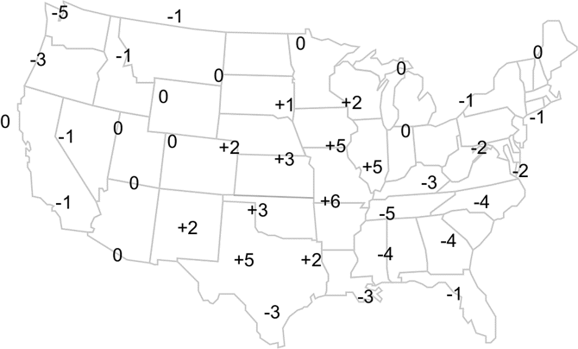

**19a. Draw in the edge of the cold front**

**19b. Draw in a black line where the cold and warm front meet**

**19c. Draw in the edge of the warm front (there are 2 areas!)**

1. **Bob watched the weather with his parents on Thursday night. He told his dad that he should take an umbrella with him because there is a warm front moving in that will bring warmer temperatures, but also rain to the area. He also told him that it’s going to be pretty sticky since humidity would be also be increasing. Is Joe’s explanation of the weather correct or incorrect? Explain why!**
2. **Joe Calhoun stated that as the low pressure system moves over Pennsylvania the weather will continue to improve bringing sunny skies and nice weather to the region. Is Joe’s forecast accurate? Why or Why Not?**
3. **Sally was studying her notes for her meteorology test when she noticed she was missing information. She had written down that as temperatures decrease a cold front is approaching and thunderstorms will take place. But, she had nothing about air temperature and humidity. If you were her partner, what would you tell her happens to air pressure and humidity during a cold front? Why?**
4. The figure below shows a low pressure system over the central plains. In the figure, **the fronts are denoted by I and II**, the areas with clouds are encircled by the dash-dot line, and the dotted line is the 0°C line.

**23a. Identify what types of front is located at “I”**

**23b. Identify what type of front is located at “II “**



1. You, who are at point A, are talking with your good friends that live at point B and C about the weather. **Choose the description that best fits what you or your friends would be experiencing by placing A, B, or C in front of the description.**



_____ **24a**. “Well, over here it’s been snowing quite a bit, very slushy. The winds seem to be coming from the East. The TV weather person says that we can expect more snow.”

_____**24b**. “Over here it was sunny and warm, really nice this morning, but now there are severe weather alerts everywhere!”

_____**24c**. “Nothing much out here, it’s been cold and windy. I think the winds are coming from the northwest.

1. **An air mass is a body of air with**

a. equal density throughout

b. similar values of temperature and moisture in the horizontal

c. very high pressure everywhere

d. at least two frontal zones

e. very low humidity in its lower layers

1. **Define “front”**
2. **Where are fronts located (i.e. where do you draw them)?**
3. **Identify the type of front**

|  |  |
| --- | --- |
| **Movement of air masses** | **Type of front** |
| An advancing warm air mass displaces a cold air mass and glides over the top of it. | a. |
| Two air masses with similar temperatures and pressures meet, and neither advances into the other's territory. | b. |
| A cold, dense air mass displaces a warm air mass and forces the warm air to rise steeply. | c. |
| A warm air mass is squeezed upward between two cold air masses. | d. |

1. **Complete the chart on Fronts**

|  |  |  |  |  |
| --- | --- | --- | --- | --- |
| **Name of Front** | **How it moves**  **(quickly, slowly, etc)** | **Summer Weather** | **Winter Weather** | **Symbol on a map** |
| Occluded |  |  |  |  |
|  | May take a day or more to move through |  |  |  |
|  |  |  |  | http://ts2.mm.bing.net/th?id=H.4577577016099921&pid=1.7&w=212&h=124&c=7&rs=1 |
|  |  |  | Extended periods of snow |  |

1. **In the figure, what type of front is coming through Canada and into Colorado?**
2. Warm b. cold c. stationary d. occluded

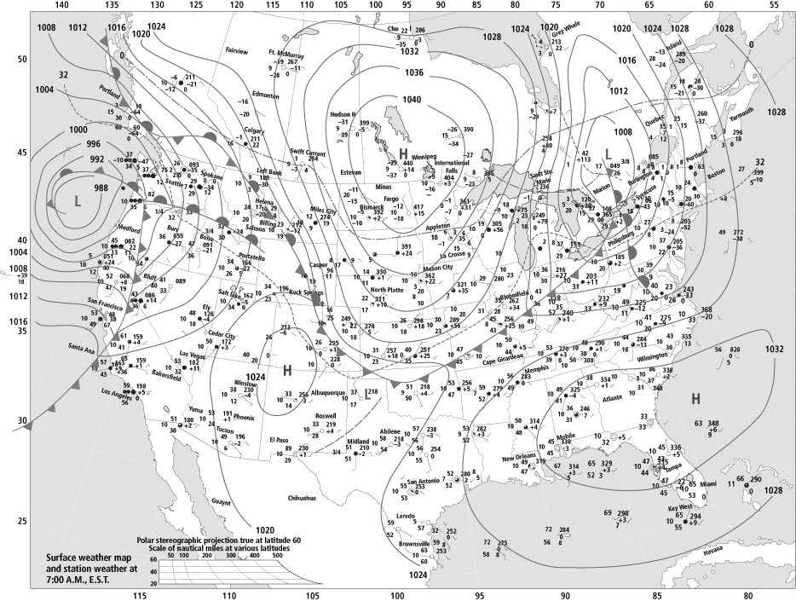

1. **In the diagram, locations *A* and *B* on the map of North America are source regions for air masses. Compared to the air mass formed at location *B*, the air mass formed at location *A* will normally be?**



a. cooler and drier

b. warmer and drier

c. cooler and wetter

d. warmer and wetter

1. Meteorologists classify air masses according to the general temperature and moisture of the region where they form. The terms ‘maritime’ and ‘continental’ refer to the amount of moisture in the region while the terms ‘arctic’ and ‘tropical’ refer to the general temperature of the region. The map below shows the general location of the typical air masses we see over North America. **Match the air mass name with the best description of its temperature and moisture.**

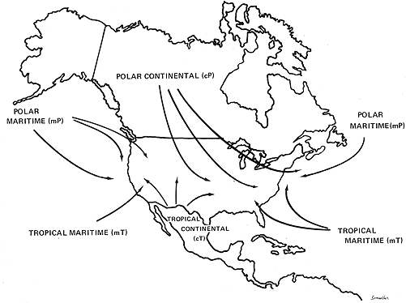

1. Cold and Dry B. Warm and Moist C. Cool and Moist D. Warm and Dry

_____ Maritime Polar Air mass

_____ Continental Polar or Arctic Air mass

_____ Maritime Tropical Air mass

_____ Continental Tropical Air mass

1. **Explain the 3 factors in cloud / fog formation.**
2. **These “wispy” clouds are formed from ice crystals and are found in higher altitudes.**
3. **What type of clouds are towering clouds with anvil heads that bring thunderstorms?**
4. Nimbostratus b. cirrocumulus c. cumulonimbus d. cirrus
5. **A cumulus cloud is recognized mainly by its**
6. obvious vertical dimension
7. darkness or color
8. precipitation
9. layered structure
10. **The temperature scale where 0 degrees represents freezing and 100 degrees boiling is called:**
11. Fahrenheit
12. Celsius
13. Kelvin
14. Absolute.
15. **What type of precipitation is associated with temperature inversion?**
16. sleet b. freezing rain c. hail d. snow
17. **What type of precipitation is associated with being a solid when it leaves a cloud and a solid when it hits the ground?**
18. Sleet b. rain c. snow d. hail
19. **Explain the other three(3) types of precipitation not reviewed in questions 39 and 40.**
20. **How do clouds impact temperature?**