Name: __________________________________ Period: ____ Date: _________________

Key Learning: Work is required to change energy; energy is required to do work.

Unit Essential Question: How can we use the concept of work to describe the changes in energy a system goes through?

Concept: Momentum |  | Concept: Work and Energy
Lesson Essential Questions:  1. How can the conservation of momentum be used to explain common phenomena?  2. How do forces, and the time during which they act, affect the momentum of an object? |  | Lesson Essential Questions:  3. How are force, work, energy, and power related?  4. How can we use the Law of Conservation of Energy to describe energy transformations?  5. How do simple machines affect the force required to complete work?
Vocabulary:  Momentum  Law of conservation of momentum  Elastic Collision  Inelastic Collision  Impulse |  | Vocabulary:  Work  Joule  Power  Watt  Energy  Kinetic Energy  Potential Energy  Law of Conservation of Energy  Mechanical Advantage
Objectives

In order to demonstrate one’s competence in this area, the student will be able to:

Section 1 Momentum & Impulse

- Define all vocabulary terms.
- Calculate momentum given the mass and velocity in terms of mv.
- Calculate impulse given mass, velocity, force or impact time.
- Define impulse and relate it to momentum.
- Give examples of how both the size of the force and the length of the time interval affect the change in momentum.
- State the law of conservation of momentum and use it to calculate velocity.
- Distinguish between an elastic collision and an inelastic collision.

Section 2 Work and Energy

- Define all vocabulary terms.
- Calculate force, work, power, kinetic energy, and potential energy if given appropriate information.
- Use the law of conservation of energy to describe energy changes between potential and kinetic.
- Describe how simple machines decrease the force required to complete work.
- Describe the mechanical advantage of a simple machine in terms of effort force and effort distance.

Section 1: Momentum and Impulse. Solve the problems and show work.
- Calculate the momentum of a 30 kg object moving at 4 m/s. _________________

- If a 150 N force is applied to a ball for 0.2 seconds, then what is the impulse delivered to the ball? _________________

- How much momentum does a 120 kg football player have when he is running at 3.5 m/s?

_________________

- How much force would be required to stop the football player in problem 3 in 0.5 seconds?

_________________

- How much force would be required to stop the football player in problem 3 in 0.25 seconds?

_________________

- A 2 kg ball moving at 0.8 m/s hits an identical ball. Before the collision, the second ball was at rest. After the collision, the first ball is at rest. What is the speed of the second ball after the collision? Explain your answer.
________________

__________________________________________________________________________________________________________________

- A 2 kg ball moving at 0.8 m/s hits a heavier ball. Before the collision, the second ball was at rest. After the collision, the first ball is at rest. Is the speed of the second ball after the collision greater or less than the speed of the first ball before the collision? Explain your answer.
________________

__________________________________________________________________________________________________________________

- A gun is fired. The mass of the gun is 2 kg. The mass of the bullet is 0.02 kg. The velocity of the bullet after being shot is 300 m/s. Determine the recoil velocity of the gun.

________________

- Suppose a bug collides with the windshield of a car. Circle which of the following will be the same for both the bug and the car:
  - Force
  - Time of impact
  - Impulse
  - Change in momentum
  - Acceleration
  - Damage

- Explain why you chose your answers for question 5.

- Is this an example of an elastic or an inelastic collision? Explain.

Page 1

- What should you do if you want to maximize the change in an object’s momentum? Give an example of this.

- What should you do if an object’s momentum will be changed by a set amount, but you want to place the maximum force on the object? Give an example of this.

- What should you do if an object’s momentum will be changed by a set amount, but you want to place the minimum force on the object? Give an example of this.

Page 2

Section 2: Work & Energy

1. The unit of force is __________________________________

2. The unit of work is ___________________________________ or __________________________________

3. The unit of power is _________________________________ or ___________________________________

Show work for all problems. Write your answer with a label on the line.

4. A box is pushed a distance of 12 m with a force of 60 N that is in the same direction as the box moves. How much work is done on the box?
____________________

5. How much power is required if it takes 10 seconds to do 500 J of work? ____________________

6. How much work is required to move a box a distance of 3 meters using a force of 75N in 5 seconds?

____________________

7. How much power is required to move a box a distance of 3 meters using a force of 75N in 5 seconds?

___________________

8. If the applied force is 150N and the force of friction is 100N, how much work is done to move a box 6m?
___________________

9. If 60 Joules of work is completed by moving a crate 12 meters, how much net force is applied?

___________________

Page 3

Use the following diagram to answer questions (1-10) below.
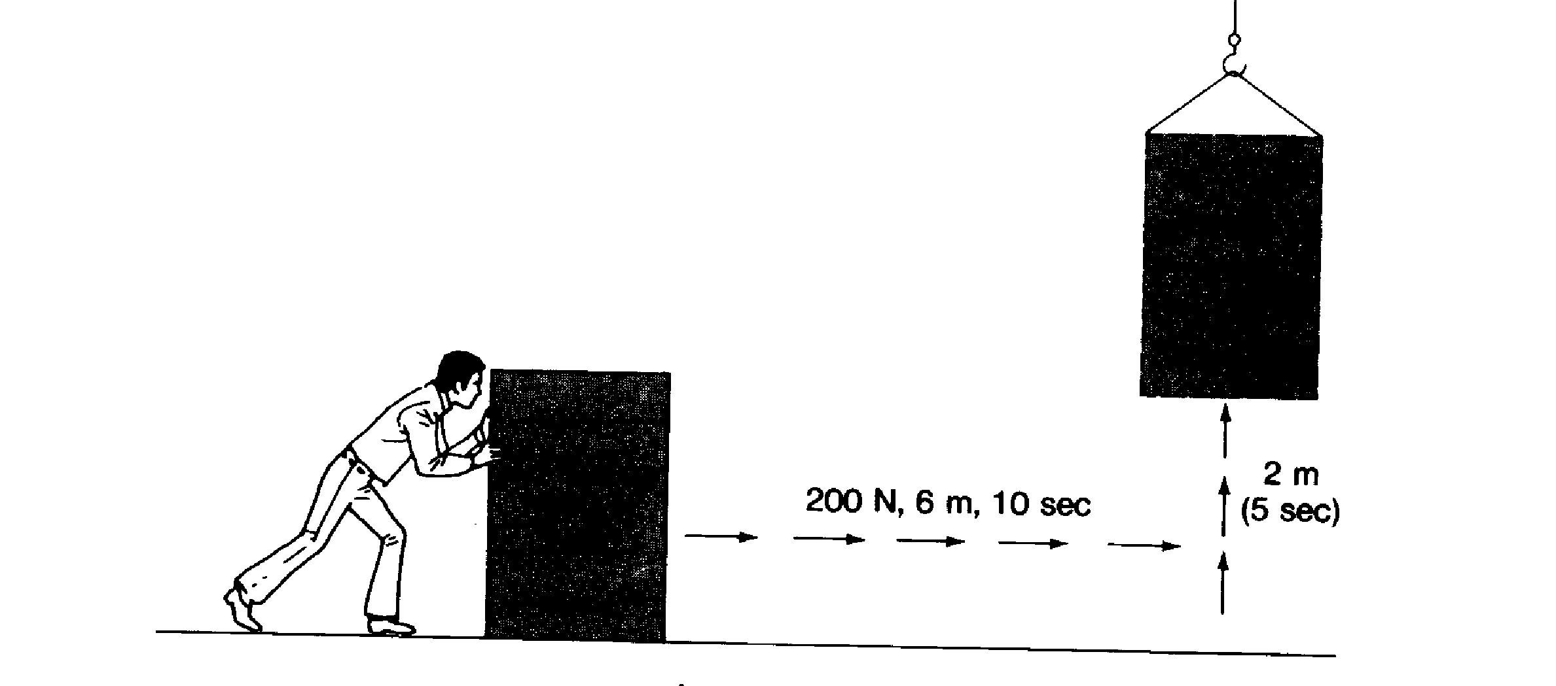
125N, 10m, 15 sec
2 m
4 sec
The weight of the box is 500 N
1. Force to slide = ___________________ 4. Force to lift = ___________________

2. Distance slid = __________________ 5. Distance lifted = ___________________

3. Time to slide = _________________ 6. Time to lift = _________________

Show work and solve the problems below

7. How much work was done sliding the box? ____________________

8. How much power was required to slide the box? ____________________

9. How much work was done lifting the box? ____________________

10. How much power was required to lift the box? ____________________

Page 4
Use the following diagram to answer questions 1- 5 below
25 m
5 m
Weight of box = 15 N

1. How much force is required to lift the 15 N box? ____________________

2. How much work is done lifting the 15 N box to a height of 5 m? ____________________

3. How much work is done sliding the box to the top of the 25 m ramp? ____________________

4. How much force is required to slide the box to the top of the 25 m ramp? ____________________

5. A pendulum with a mass of 10 kg is held at a height of 15 meters (position 1). It is then released and begins to swing as shown below. Determine the potential energy and kinetic energy for the pendulum at each position given the heights in the table.

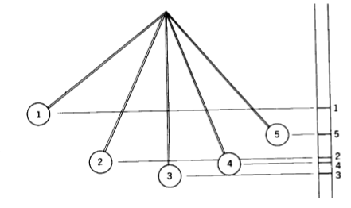
Mass of Pendulum = 10 kg
Position | Height | PE (show work) | KE
1 | 15 m
2 | 9 m
3 | 3 m
4 | 6 m
5 | 12 m

6. At which of the numbered point(s) is the kinetic energy the greatest? _________________

7. Why does this point have to have the greatest amount of kinetic energy?

8. At which of the numbered point(s) is the potential energy the greatest? _______________

9. Why does this point have to have the greatest amount of potential energy?

10. During which part of the swing is the energy transforming from potential to kinetic? From kinetic to potential? Page 5
Use the diagram below to answer questions 1 and 2.

1. What is the total energy for the object below? ____________________

2. Fill in the missing energies

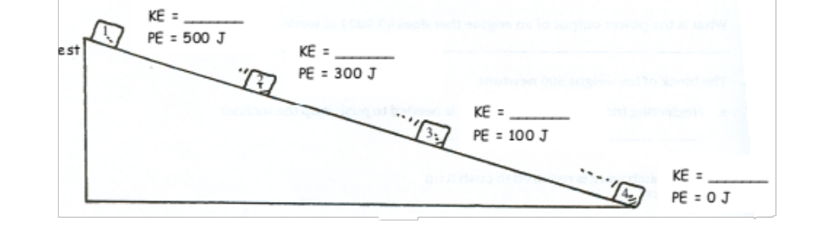
KE = 0
PE = 750J
500J
250J

3. An object that has kinetic energy has energy because of its ___________________________________________

4. An object that has potential energy may have this energy because of its: ____________________________

5. What law allows us to complete the calculations above? ______________________________________________

Solve the following and show work.

6. What is the kinetic energy of a 30 kg object moving 2 m/s? ____________________

7. What is the potential energy of a 40 kg object at a height of 4 m? ____________________

8. What is the potential energy of a 75N object at a height of 2 m? ____________________

9. What is the kinetic energy of a 36 kg object moving 4 m/s? ____________________

Page 6
Use the following diagram to answer questions 1- 5 below
10 m
2 m
Weight of box = 20 N

1. How much force is required to lift the 20 N box? ____________________

2. How much work is done lifting the 20 N box to a height of 2 m? ____________________

3. How much work is done sliding the box to the top of the 10 m ramp? ____________________

4. How much force is required to slide the box to the top of the 10 m ramp? ____________________

5. Use the distances to calculate the mechanical advantage of the ramp. ____________________

6. Circle the correct words: Using the ramp decreases the amount of ( force / work ) needed because it ( increases / decreases ) the distance.

7. Draw two levers: one with a lower mechanical advantage and one with a higher mechanical advantage. Label the location of the effort force, effort distance, and fulcrum. Explain why one has a higher mechanical advantage than the other.

Page 7

Define each of the following vocabulary terms in your own words:

Momentum
Law of conservation of momentum
Elastic Collision
Inelastic Collision
Impulse
Work
Joule
Power
Watt
Energy
Kinetic Energy
Potential Energy
Law of Conservation of Energy
Mechanical Advantage
Page 8

