Name: _________________________________________ Period: __________ Date: _____________________________
Unit 1: The Nature of Science
  - A Brief History of Advances in Science

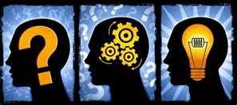
* _______________________________________________ is basic to science

Rational Thinking: searching for______________________ & _______________________ relationships

HISTORY

Where & When
Scientists

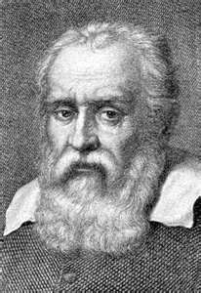
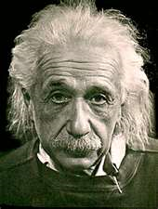
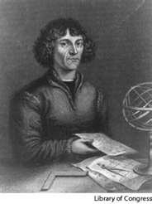

Galileo
Einstein
Copernicus

  - Mathematics and Conceptual Physical Science

- Math is a _____________________ of Science

Science Uses Math for

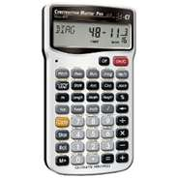
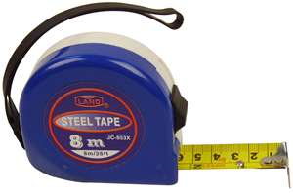

  - Science Has Limitations
Science MUST BE:
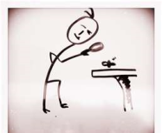
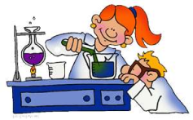

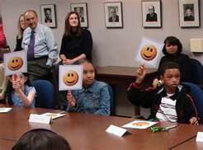

Pseudoscience Reading
What are 3 things you learned or found to be interesting from the reading
A.
B.
C.
Name 2 types of Pseudosciences
1.
2.
Give 1 definition for what a pseudoscience is
My Definition:
__________________________________________________________________________________________________

  - Technology – Practical Use of the Findings of Science

- Technology ________ __________ Science

- Technology is an _______________________________ used to conduct investigations.

  - Allows us to use our knowledge for practical purposes

Using the words in the box, write your own definition for “science”
Self-correcting common sense nature technology organized
rational verifiable supernatural observation continuous
Repeatable natural world mathematics subject to peer review

Your Definition:

Our “Simple” Definition:

