Name: _________________________________________ Period: __________ Date: _____________________________
Unit 1: The Nature of Science
  - A Brief History of Advances in Science

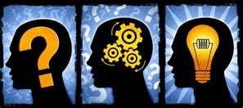
* ___Rational Thinking____________________________ is basic to science

Rational Thinking: searching for______cause_________ & ____effect________ relationships

HISTORY

Where & When
Scientists

Greece
3rd and 4th centuries BC
“Modern Science”
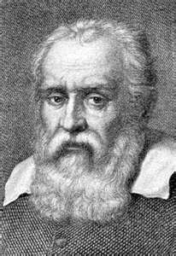
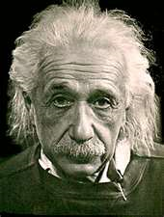
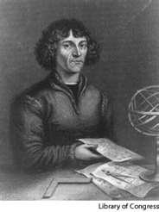

Galileo
Einstein
Copernicus
Italian Physicist
Used experiments, not speculation, to study nature’s behaviors
Stated “…it only takes one experiment, provided it is repeatable, to show that I am wrong.”
Polish Astronomer
Idea:
Sun is stationary, Earth revolves around the sun

  - Mathematics and Conceptual Physical Science

- Math is a ______tool_______________ of Science

Science Uses Math for

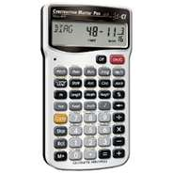
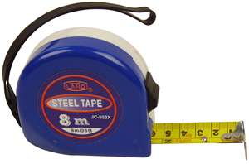

calculations

measurements

  - Science Has Limitations
Science MUST BE:
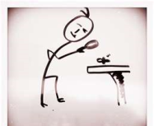
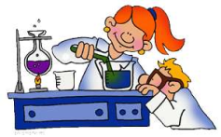

observable

testable

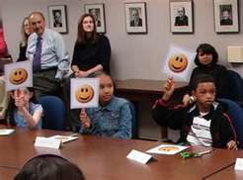
Subject to peer
review
Part of the
natural world

repeatable

verifiable

Self-correcting

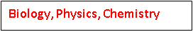
Math, Technology, Supernatural
Biology, Physics, Chemistry
Pseudoscience Reading
What are 3 things you learned or found to be interesting from the reading
A.
B.
C.
Name 2 types of Pseudosciences
1. Astrology
2. Phrenology
Give 1 definition for what a pseudoscience is
My Definition:
__________________________________________________________________________________________________

  - Technology – Practical Use of the Findings of Science

- Technology __IS______ _____NOT_____ Science

- Technology is an ______instrument_________________ used to conduct investigations.

  - Allows us to use our knowledge for practical purposes

Using the words in the box, write your own definition for “science”
Self-correcting common sense nature technology organized
rational verifiable supernatural observation continuous
Repeatable natural world mathematics subject to peer review

Your Definition:

Our “Simple” Definition: A body of knowledge about nature

