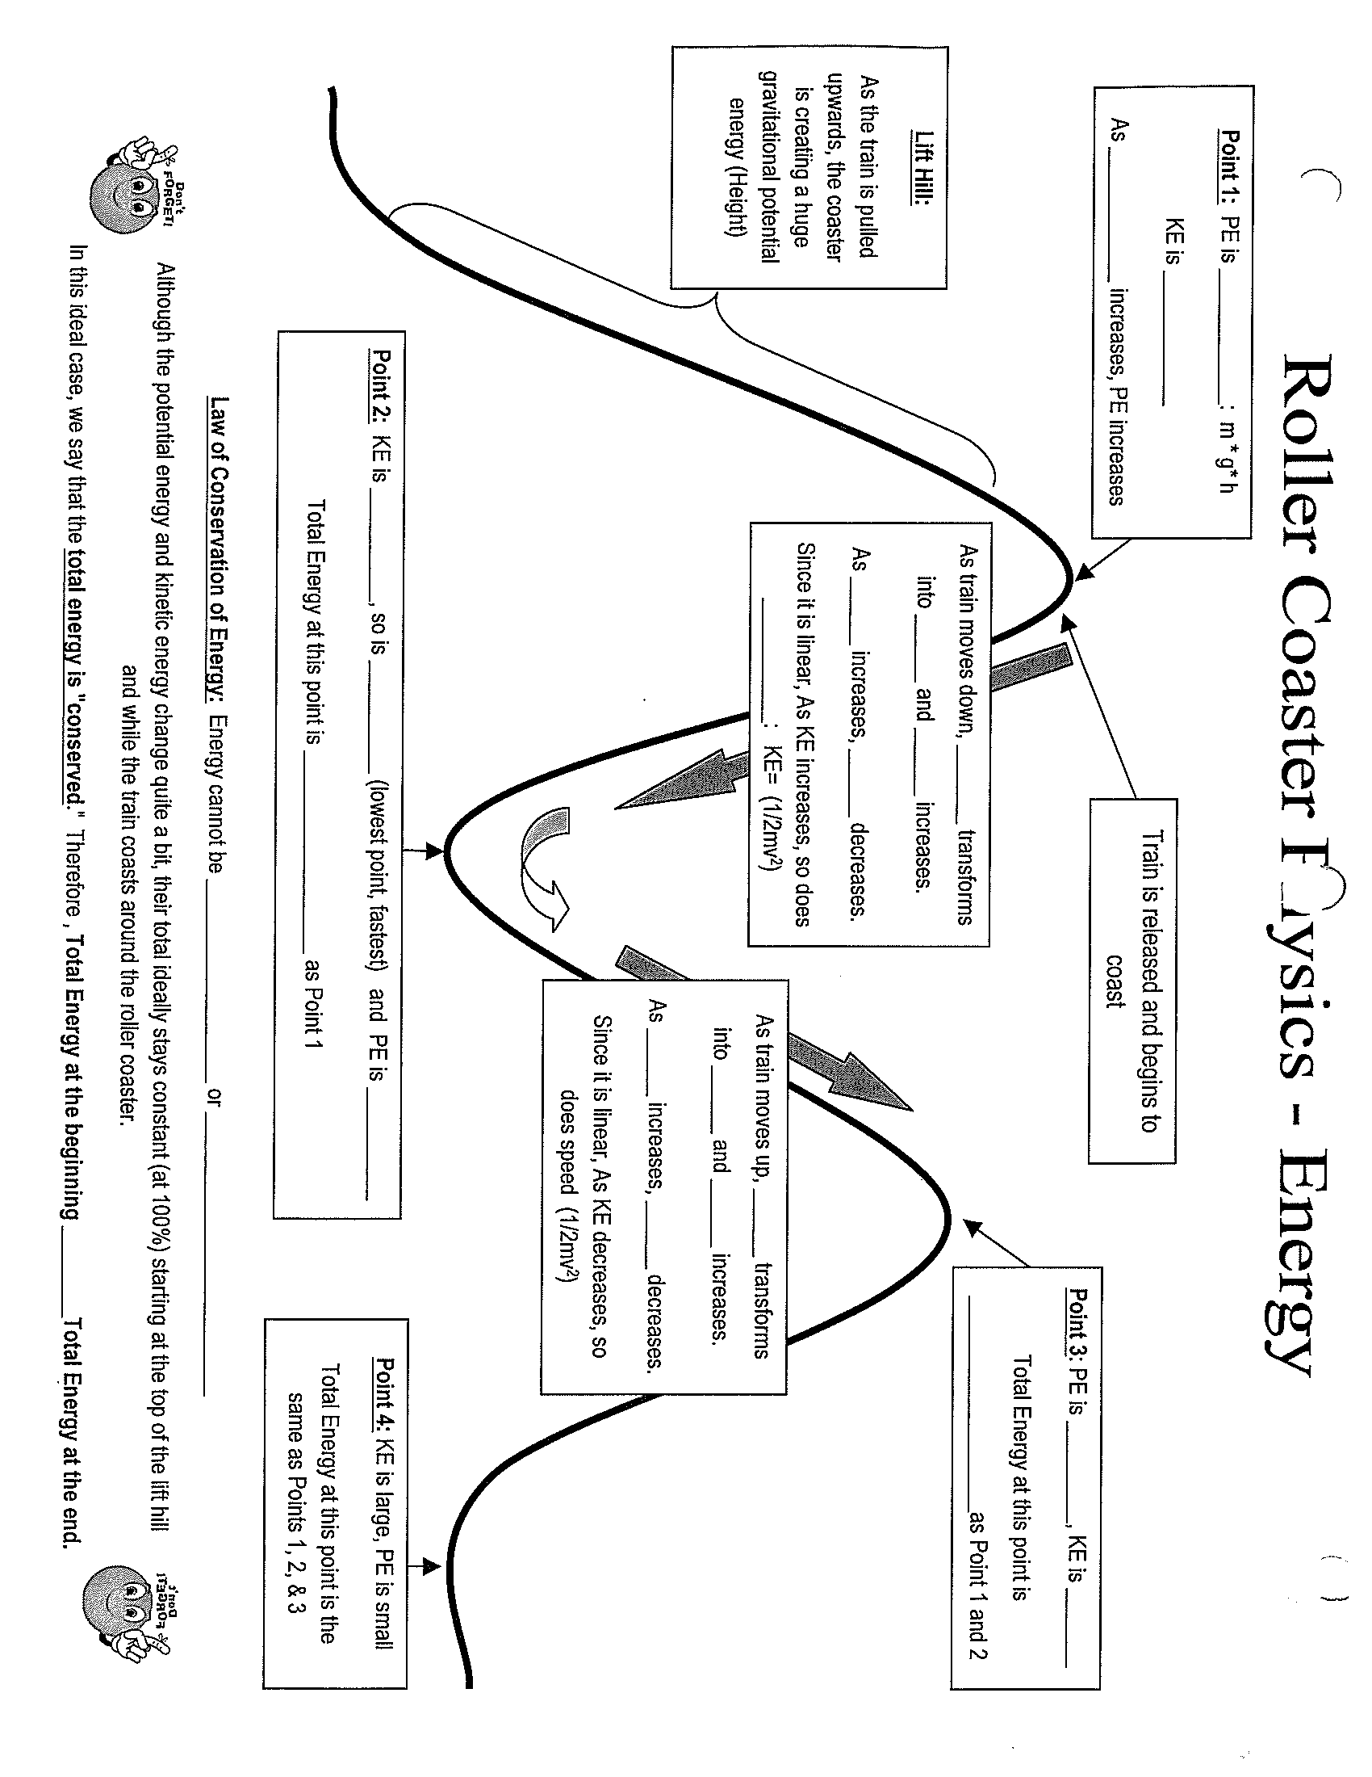

The WORK done to lift it to the height

equals the __________ at the height

Roller Coaster Physics - Energy