Name: _______________________________________ Pd.________ Date: ____________________________________
Soils Study Guide
- Soil is a naturally occurring body of thick layers comprised of what two (2) things?

  - _____________________________________

  - _____________________________________

- What are the three (3) ways that soil differs from parent material?

  - ______________________________________

  - ______________________________________

  - ______________________________________

- There are five (5) soil-forming factors. Using the word bank, match the word to the correct soil forming factor:

climate organics slope time parent material

________________________________ vegetation and animals (both decaying and root action)
________________________________ how long it has been there (age)
________________________________ the amount of rain and other biological factors
________________________________ amount of water runoff
________________________________ type of rock the soil is made of

- What two (2) things can soil color tell you?

  - _____________________
  - _____________________

- What is used to determine soil color?

  - Mercalli Color Scale
  - Morse Color Coding
  - Munsell Color Chart

- Match the Soil Color term with the correct definition

- The lightness or darkness of the color _____ Hue
- The strength or depth of color _____ Value
- The relation of the color to red, yellow, green, blue or purple. _____ Chroma

- Below is a Soil Color Test Page. Label the boxes with the following information: Chroma, Hue, Value

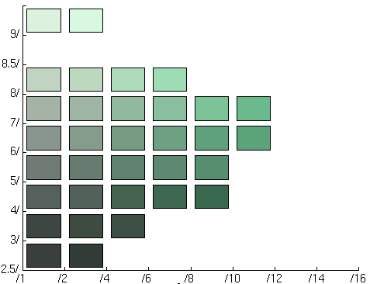
5g

- Given the following: 6R2/7, identify the following:
Value: _______ Hue: ________ Chroma: _________

- How does weathering differ from erosion?

- There are two types of weathering. Complete the weathering chart noting the types of weathering and the things associated with each type of weathering.
Types of Weathering
Things associated with that type of weathering

- What three things cause erosion?

  - _______________________________
  - _______________________________
  - ________________________________

- Write the name of each type of coarse faction next to the correct size.
__________________________________ 75mm – 200mm
__________________________________ greater than 600mm
__________________________________ 2mm - 75mm
__________________________________ 250mm – 600mm

- Write the name of each soil separate next to the correct size.
___________________________________ smallest
___________________________________ mid-sized
___________________________________ largest

- Using the textural triangle, identify the type of soil present.
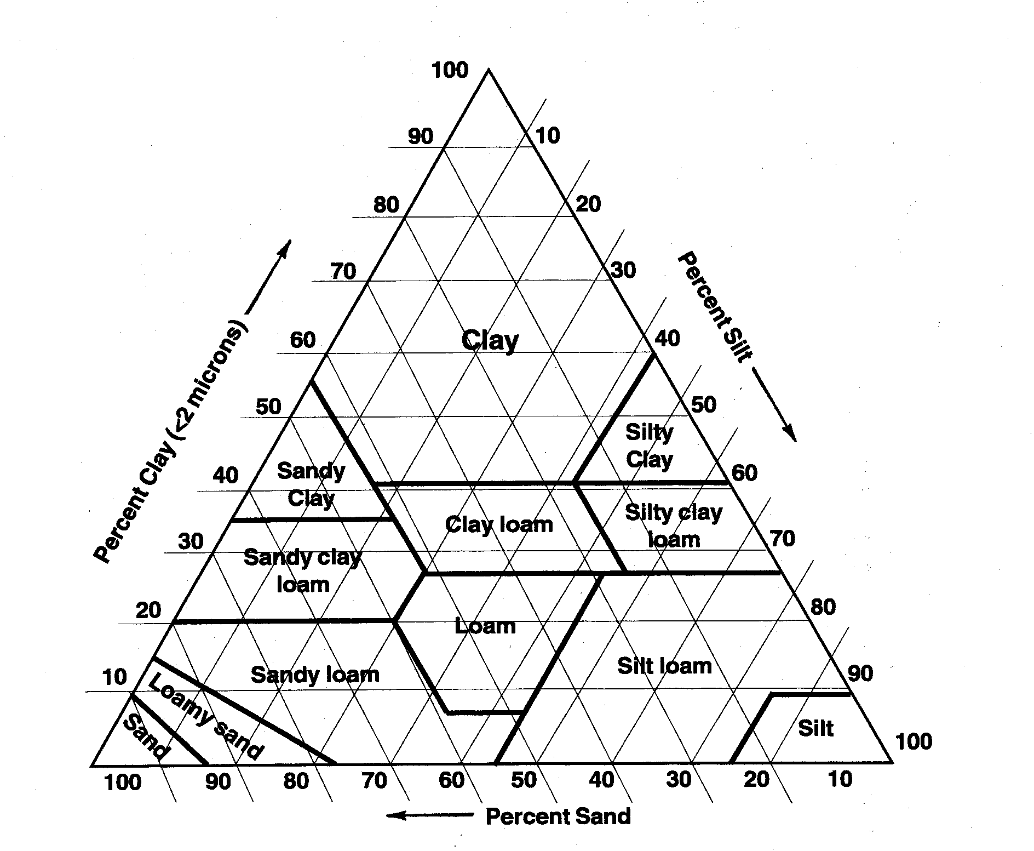
 | Percent Sand | Percent Silt | Percent Clay | Soil Texture
Soil 1 | 93 | 6 | 4
Soil 2 | 34 | 21 | 62
Soil 3 | 50 | 17 | 31
Soil 4 | 10 | 43 | 48
Soil 5 | 45 | 35 | 20

- Using the words sand, silt, clay or loam; answer the following questions:

- Which soil separate would allow water to drain the fastest?

B. Which soil separate would not allow water to drain easily?

- Which soil separate decreases porosity?

D. Which soil separate increases permeability?

E. Which soil type is considered a perfect soil? Why?

- Match the soil horizon with the correct definition

B Horizon R Horizon A Horizon E Horizon C Horizon O Horizon

________________ - Also called regolith. It consists of slightly broken-up bedrock. Plant roots do not penetrate into this layer; very little organic material is found in this layer.

_________________ - This eluviation (leaching) layer is light in color; It is made up mostly of sand and silt, having lost most of its minerals and clay as water drips through the soil (in the process of eluviation).

_________________ - Also called the subsoil. It contains clay and mineral deposits (like iron, aluminum oxides, and calcium carbonate) that it receives from layers above it when mineralized water drips from the soil above.

__________________ - The unweathered rock (bedrock) layer that is beneath all the other layers.

__________________ - The top, organic layer of soil, made up mostly of leaf litter and humus (decomposed organic matter).

__________________ - The layer called topsoil; Seeds germinate and plant roots grow in this dark-colored layer. It is made up of humus (decomposed organic matter) mixed with mineral particles.

- Label the Soil Horizons in the picture below. (Use the Horizons above for labeling)
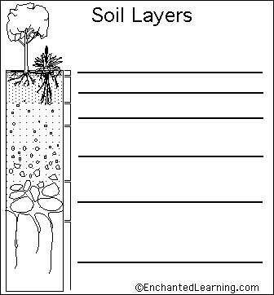

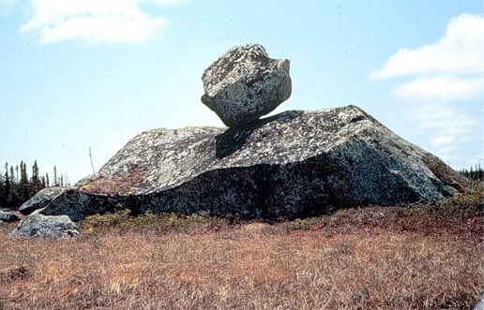
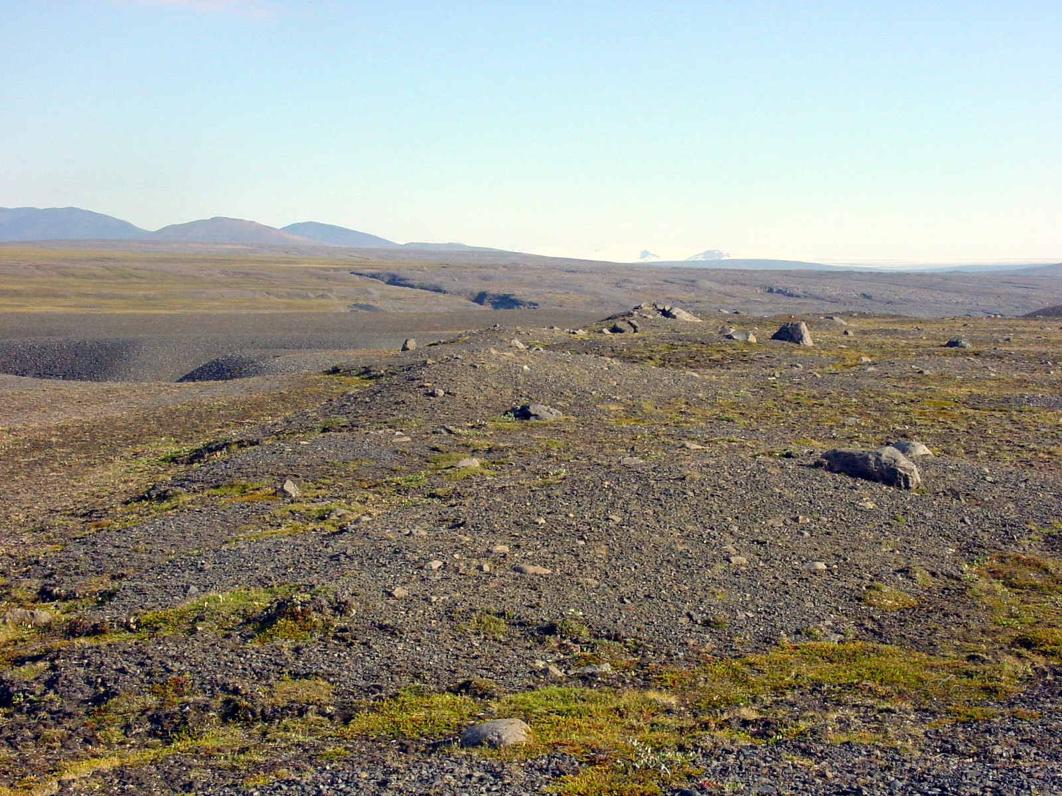
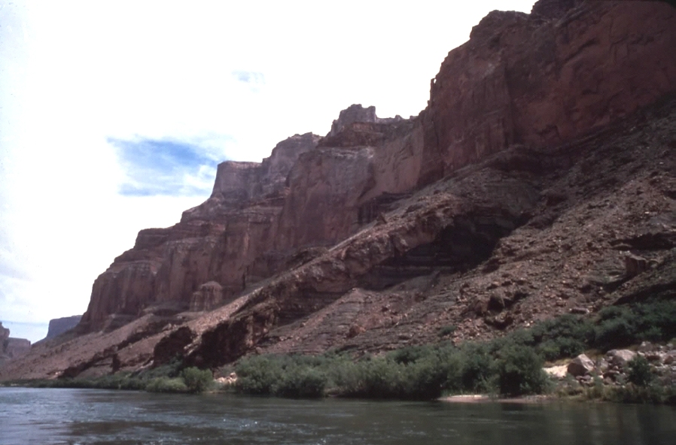
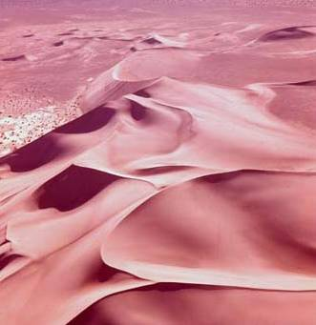
- Complete the Parent Materials Graphic Organizer
Residual Parent Material
Definition: _________________________________
___________________________________________

Transported Parent Material
Definition: Parent material that is

In Situ
Parent Material moved by a
_________________ or
__________________________________
___________________
Parent Material moved by
_________________
Generally found in
_________________

Parent Material moved by
_________________
(________________)

Parent Material moved by a
_________________ or
_________________

